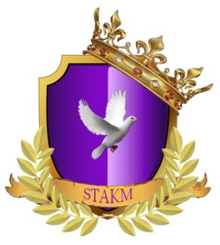
Ministry Training Class
Class Four – The Book of Revelation

- How long is the tribulation period?
- How long does the Millennial Kingdom last?
- When does Christ setup this Kingdom?

- What did John see when he turned to see the voice talking to him?

- What or who was in the midst of what he saw?
- What was in the right hand of the person John saw?
- What are the seven stars?
- What are the seven candlesticks?

- How many churches did John write to?
- What were the names of the churches John wrote to and where were they located?

TOTAL
SCORE

