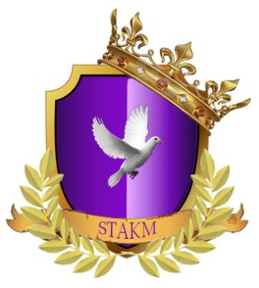
Ministry Training Class
Class One – People in the Bible

- Who were Adam & Eve’s children?
- Who killed whom from their children?
- Who was Seth?
- Who was Enoch?
- Who walked with God and then was no more?
- Who was Methuselah?
- How long did Methuselah live/how old was he?
- Who was Methuselah’s son?
- Who was Lamech?
- Who was the son of Lamech?
- Lamech’s son had three sons. What were their names?

- Who was Noah?
- What did God instruct Noah to build?
- How many people were saved with Noah?
- Who was Ham?
- What was significant about Ham?
- Who was Nimrod?
- What significant thing did Nimrod do?
- Who was Abram and what later was his name?

- Who was Abram’s wife and what later became her name?
Each question is worth 5 pts. TOTAL
SCORE

